This problem will be worth 16 points. Each successfully implemented function will earn you a point. There is the one student tester and one test for each of the 10 functions for a total of 11 tests. Additional bonus points will be awarded for correctly implementing functions 1-3, functions 4 - 6, functions 7and 8, functions 9 and 10 and a final bonus point for correctly implementing all 10 functions in this class.

This problem will ask you to implement the following functions. One function is defined recursively. Other times I will give you functions from the java.lang.Math with a brief description, and some times you just need to implement the function. In all the following functions you do NOT need worry about domain issues. That is, you may assume that all test data will not cause any exceptions to be thrown. In total, there are ten different functions in this problem. All methods which return a double must return value within 0.05 of the correct answer to be considered correct.

You should use:
- Math.max(a,b) for max{a, b}. | - Math.min(a, b) for min(a, b)
- Math.abs(x) for |x|. | - Math.cos(a) for cos(a)
- Math.sqrt(x) for 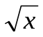 | - Math.sin(a) for sin(a)
- Math.pow(x, 1.0/n) for 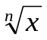 | - Math.tan(a) for tan(a)
- Math.log(a) for 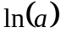 | - Math.log10(a) for 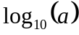 or 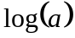
- Math.ceil(a) for 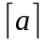. | - Math.floor(a) for 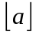.

note:
- Return type of Math.abs, Math.max and Math.min is the same as its argument(s).
- Return type of all other methods is double.
- 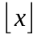 is the largest (Closes to positive infinity) double value smaller than or equal to x. For example, 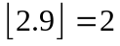 and 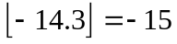.
- 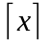 is the smallest (Closes to negative infinity) double value that is greater than or equal to x. For example, 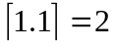 and 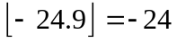.
- Use the following constant for pi (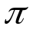)
Math.PI | The double value that is closer than any other to pi, the ratio of the circumference of a circle to its diameter.
- Use the following constant for 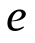
Math.E | The double value that is closer than any other to e, the base of the natural logarithms.

- Implement the following integer recursive function. All calculations shall be computed using Integer
math.
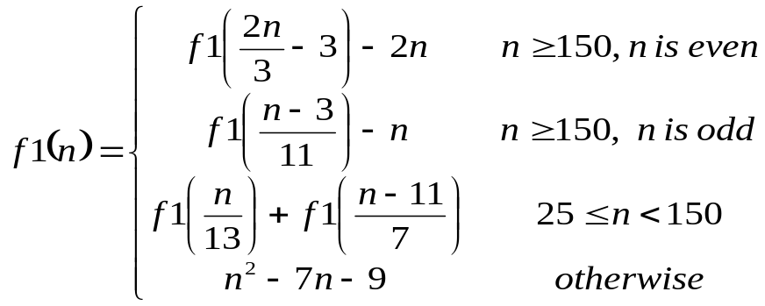
using the following function heading:
public static int f1(int n)

Test data: f1(11) returns 35
f1(44) returns -42
f1(389) returns -429

The correct call to a recursive static method is of the form: FunctionsGoneWild2017.f1(n)

- Implement the following function.
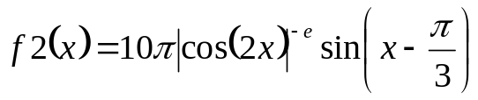
Use the following function heading:
public static double f2(double x)

Test data: f2(7) returns -2275.836497

The correct call to the static method is of the form: FunctionsGoneWild2017.f2(x)

- Implement the following function
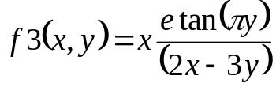

Use following function heading:

public static double f3(double x, double y)

Test data: f3(5.0, 3.2) returns 24.6868

The correct call to the static method is of the form: FunctionsGoneWild2017.f3(x, y)

4. Implement the following function
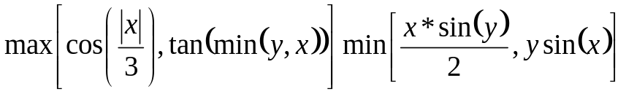,
Use following function heading:
public static double f4(double x, double y)

Test data: f4(50.51, 86.7855) returns -5.8241

The correct call to the static method is of the form: FunctionsGoneWild2017.f4(x, y)

5. Implement the following function
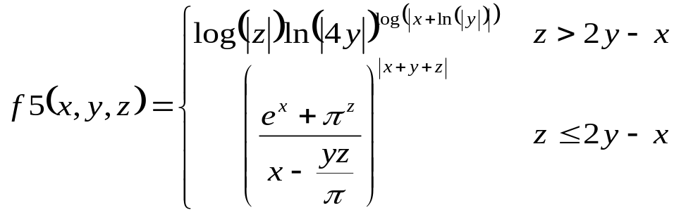
Use following function heading:
public static double f5(double x, double y, double z)

Test data: f5(1, 3, 8) returns 1.21058
f5(2, 4, -1) returns 72.38373

The correct call to the static method is of the form: FunctionsGoneWild2017.f5(x, y, z)

6. Implement the following function
Consider the mathematical notation 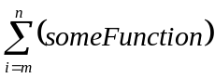 used to represent the summation of many similar terms. The notation 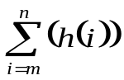 is defined as:
The subscript gives the symbol for an index variable, i. Here, i represents the index of summation; m is the lower bound of summation, and n is the upper bound of summation. In this case, i = m under the summation symbol means that the index i starts equal to m. Successive values of i are found by adding 1 to the previous value of i, stopping when i = n. An example: 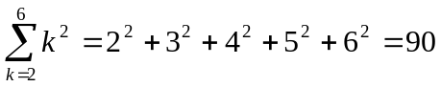.

Your task in this problem is to implement the following function.
Special note – all calculations are to be completed using integer math

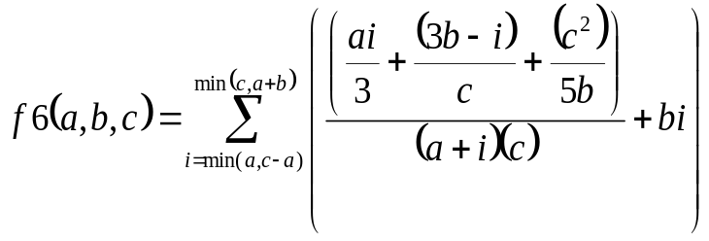 =
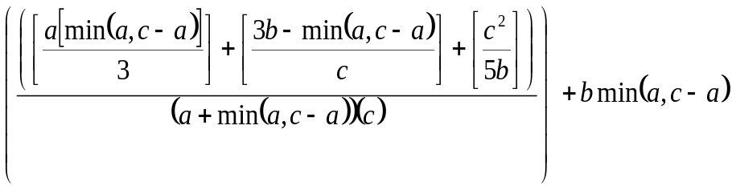
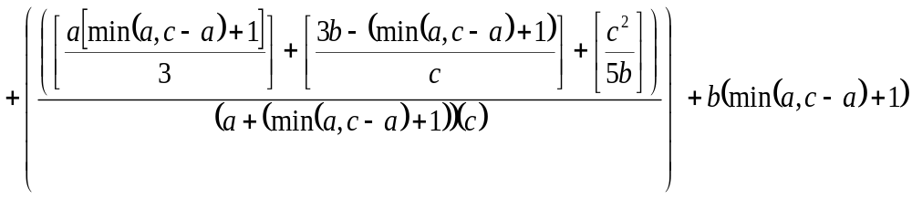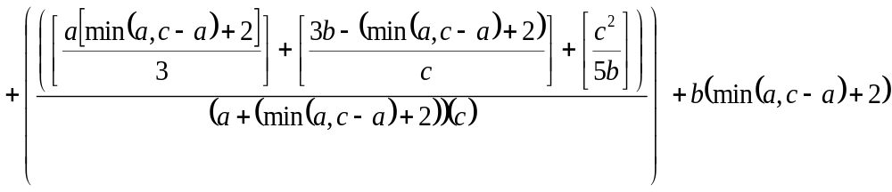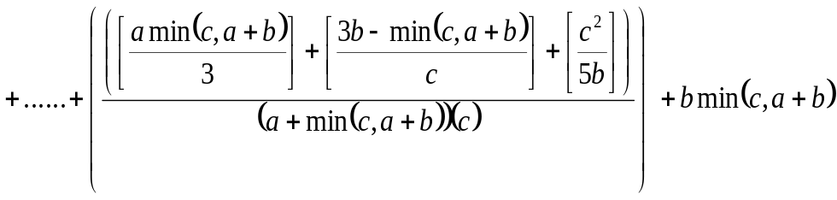
Use the following function heading: public static int f6(int a, int b, int c)

Special Note: return 0.

Test data: f6(5, 2, 7)
Returns =4+6+8+10+12+14 = 54

The correct call to the static method is of the form: FunctionsGoneWild2017.f6(a, b, c)

7. Implement the following function
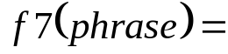Scramble the String phrase by replacing each individual letter with the letter to the right on the keyboard. You only need to worry about Capital letters (and spaces are left unchanged), Replace the letters at the far right of the keyboard with the letter to the far left of the keyboard. That is, replace P with Q, L with A and M with Z.

Use following function heading:

public static String f7(String phrase)

Special Note: phrase.length() >= 0.

f7 Test data
Test data:
f7(“COMPUTER SCIENCE”) returns “VPZQIYRT DVORMVR”

The correct call to the static method is of the form: FunctionsGoneWild2017.f7(str)

8. Implement the following function
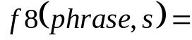 Return a String with all occurrences of every element of s removed from phrase. Order of letters in phrase is maintained.

For example,
&

Use following function heading:
public static String f8(String phrase, String s)

Special Note: phrase.length() >= 0
s.length() >= 0
And phrase and s will contain only Upper case letters and spaces.

f8 Test data
f8(“ANALOGICAL”, “AL”) return “NOGIC”
f8(“COMPUTER SCIENCE”, “RE P”) return “COMUTSCINC”
9. Implement the following function
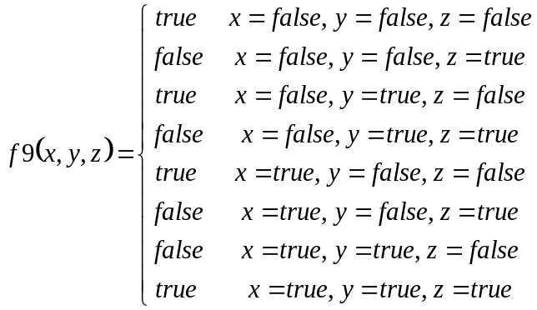
Use following function heading:
public static boolean f9(boolean x, boolean y, boolean z)

Test data: f9(false, false, false) returns true

10. Implement the following function
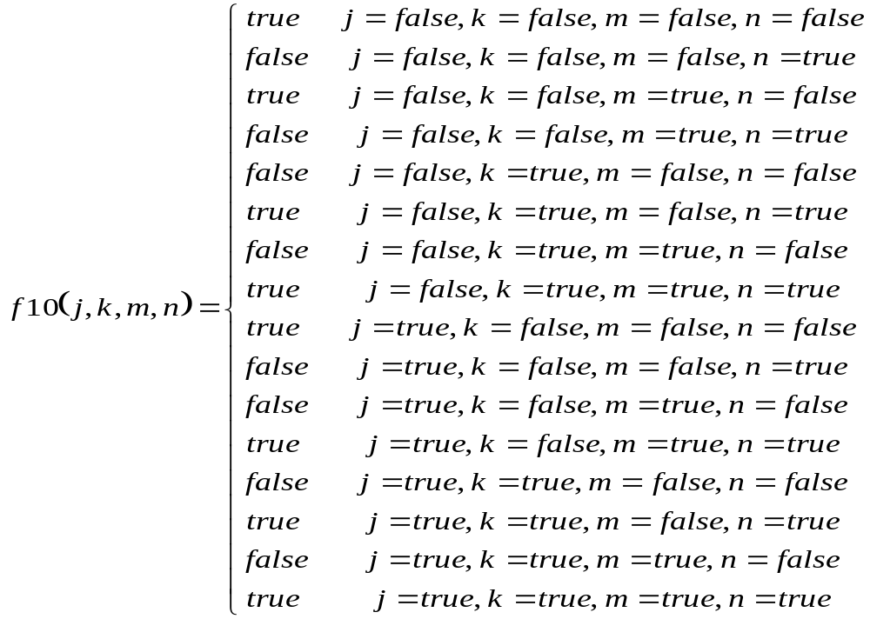
Use following function heading:
public static boolean f10(boolean j, boolean k, boolean m, boolean n)

Test data: f10(false, false, false, false) returns true

